Bangladesh University of Engineering and Technology (BUET)
Department of Industrial and Production Engineering (IPE)


Course No: AEM 6209
Course Title: Supply Chain Management

Project Report 1: Demand Forecasting and Inventory Optimization using RevIN-TSMixer: Evidence and Bangladesh Adaptation

Submitted to
Dr. Ridwan Al Aziz
Assistant Professor, Department of IPE, BUET

Submitted by
Team No – 13
Md. Rabby Shajin Islam (Team Leader) ID- 1024082024
Mostafizur Rahman Khan ID- 0424082030
Table of Contents
1. Research Gap 5
2. Research Objectives and Questions 6
3. Methodology 8
3.1. Overview 8
3.2. Demand forecasting 9
3.2.1. Forecasting problem formulation 9
3.2.2. TSMixer model 9
3.2.3. RevIN method 12
3.2.4. RevIN-TSMixer model 14
3.3. Probabilistic inventory model 14
3.3.1. The continuous review policy $(r,q)$ 14
3.3.2. Determination of total costs 15
4. Data Summary 17
5. Answers to Research Questions 18
6. Future Research Directions 20
7. Implementation in the Context of Bangladesh 21
7.1. Purpose and positioning of this section 21
7.2. Why Bangladesh is not “Vietnam with different numbers” 21
7.2.1. Lead-time volatility tends to dominate inventory error 21
7.2.2. Demand is event-driven and calendar-shocked 22
7.2.3. Data coverage and quality are uneven by design 22
7.3. Bangladesh use case: FMCG distribution (Dhaka–Chattogram corridor) 23
7.3.1. Target industry and operational structure 23
7.3.2. Why FMCG fits the paper’s framework 23
7.3.3. Practical unit of analysis 23
7.4. Data modifications (Bangladesh-specific): designing a feature set that survives shocks 24
7.4.1. Internal (firm-level) demand and commercial drivers 30
7.4.2. Macro and market context (Bangladesh) 30
7.4.3. Operational and lead-time data 31
7.5. Model modifications: making RevIN-TSMixer decision-stable in Bangladesh 32
7.5.1. Missingness should be handled intentionally 32
7.5.2. Event-aware inputs must be added, and evaluation must be split by event windows 32
7.5.3. A two-stage training and selection strategy should be institutionalized 33
7.6. Inventory modifications: adapting the $(r,q)$policy to Bangladesh operational risk 33
7.6.1. Lead time should be treated as variable 34
7.6.2. Shortage cost estimation should be operationalized 34
7.6.3. Service-level targets should be segmented (not uniform) 35
7.7. Realistic Bangladesh implementation plan (end-to-end) 35
7.7.1. Phase 0: Scope and pilot boundaries 39
7.7.2. Phase 1: Data pipeline build (4–8 weeks) 40
7.7.3. Phase 2: Baselines + RevIN-TSMixer training 40
7.7.4. Phase 3: Inventory integration and two-scenario evaluation 40
7.7.5. Phase 4: Pilot rollout (human-in-the-loop decision support) 41
7.7.6. Phase 5: Operationalization and KPI review 41
7.7.7. Phase 6: Monitoring, drift detection, and shock-mode control 41
7.8. Risk controls and monitoring (Bangladesh-specific) 42
7.8.1. Shock-mode policy override 42
7.8.2. Drift detection beyond RevIN 42
7.8.3. Governance and retraining cadence 43
7.9. Bangladesh deployment checklist 43
7.10. Strategic takeaway 44
8. References 45

1. Research Gap
Inventory carrying and control expenses have been reported to constitute a substantial fraction of product value (e.g., 20–40%), thereby positioning demand uncertainty—and the ability to forecast it reliably—as a core determinant of inventory decisions (Kourentzes et al., 2020; Manatkar et al., 2016). Nevertheless, three persistent gaps continue to characterize the forecasting–inventory interface:
- Forecast accuracy does not guarantee superior inventory outcomes. Improvements in conventional predictive metrics (MAE/MSE/RMSE/MAPE) have not been sufficient to ensure optimal inventory performance, because these losses primarily reward average fit and often fail to account for asymmetric overstocking versus understocking penalties and the distributional structure of demand errors (Gneiting, 2011; Kourentzes et al., 2020; Tratar, 2010).
- Limited end-to-end coupling between forecasting objectives and inventory costs. Forecasting and inventory control have frequently been handled as two sequential stages, where inventory performance is assessed only after forecasts are produced; such a pipeline can lead to inventory policies that are cost-inefficient even when forecasting accuracy is high (Kourentzes et al., 2020).
- Shortage cost remains insufficiently modeled despite its policy-defining role. Shortage cost directly shapes service levels, reorder points, safety stock, and overall system cost; however, the way inventory outcomes change as shortage cost varies has not been systematically examined in many studies, despite its centrality to policy design (Winston, 2022).
These gaps were addressed by coupling a strong multivariate forecasting model (RevIN-TSMixer) with a probabilistic continuous-review inventory framework, and by evaluating both error-optimized and cost-optimized regimes so that the operational consequences of forecasting choices could be quantified under differing cost structures.

2. Research Objectives and Questions
The objectives were defined to move beyond a purely predictive evaluation of demand forecasting and toward an operations-oriented assessment in which forecast quality was judged by its downstream influence on inventory decisions under uncertainty. Accordingly, model development was positioned alongside inventory-policy integration so that both statistical accuracy and cost-relevant performance could be examined under alternative optimization regimes, while explicitly accounting for the role of shortage penalties in shaping reorder decisions and total cost (Douaioui et al., 2024; Goltsos et al., 2022; Kourentzes et al., 2020; Liu et al., 2023; Winston, 2022; Zuo-Jun Max Shen, 2019).
- Develop and evaluate an inventory-relevant multivariate forecasting workflow. A multivariate demand-forecasting pipeline was developed and evaluated with the explicit aim of producing forecasts that are decision-useful for inventory planning under demand uncertainty, rather than being optimized solely for statistical fit (Douaioui et al., 2024; Goltsos et al., 2022).
- Improve TSMixer robustness to distribution shift using RevIN and quantify the improvement. Reversible instance normalization (RevIN) was integrated into the TSMixer architecture so that shifts in mean and variance across time and across sequences could be mitigated, and performance gains over standard TSMixer were quantified (Liu et al., 2023).
- Couple forecasting with a probabilistic continuous-review $\left(r , q\right)$inventory model and evaluate operational metrics. The forecasting model was integrated with a probabilistic $\left(r , q\right)$policy, and safety stock, reorder point, stockout probability, expected shortage cost, and total cost were evaluated to reflect operational consequences (Winston, 2022; Zuo-Jun Max Shen, 2019).
- Compare error-optimized versus cost-optimized regimes to characterize the accuracy–cost trade-off. Two experimental scenarios—error optimization and total cost optimization—were compared to examine whether improvements in standard forecasting metrics translate into cost-efficient inventory performance (Kourentzes et al., 2020).
- Assess the role of shortage cost as a driver of inventory behavior and model ranking. Shortage cost was treated as a variable to analyze how changes in penalty structure reshape service levels, safety-stock requirements, reorder points, expected shortages, and total cost, and how these changes affect comparative conclusions across models (Winston, 2022).
The research questions were defined to test whether robustness-oriented forecasting improvements translate into inventory gains, and to determine when cost-aware optimization changes model selection relative to error-based tuning. In particular, the questions were designed to separate (i) predictive superiority under standard error metrics from (ii) decision superiority under total-cost objectives, while also quantifying how varying shortage penalties propagate through service levels and reorder decisions to affect overall cost.
RQ1: Under the error-optimization scenario, did RevIN-TSMixer outperform standard TSMixer and classical deep-learning baselines in forecasting accuracy?
RQ2: When hyperparameters were optimized for total cost, were inventory costs reduced even if forecasting accuracy metrics worsened?
RQ3: How did varying shortage cost affect stockout probability, safety stock, reorder point, expected shortage cost, and total cost across forecasting models?
RQ4: Did integrating inventory cost into forecasting optimization (Scenario 2) yield clearer separation in inventory performance than sequential evaluation under Scenario 1?
RQ5: Was RevIN-TSMixer robust across both scenarios in balancing forecasting accuracy and cost efficiency?

3. Methodology

3.1. Overview
Two experimental scenarios were introduced so that the interaction between demand-forecasting accuracy and inventory-management efficiency could be examined. The scenarios were structured to evaluate forecasting performance and the subsequent influence of forecasts on inventory decisions, and the overall methodology with the two scenarios was presented in Fig. 1.
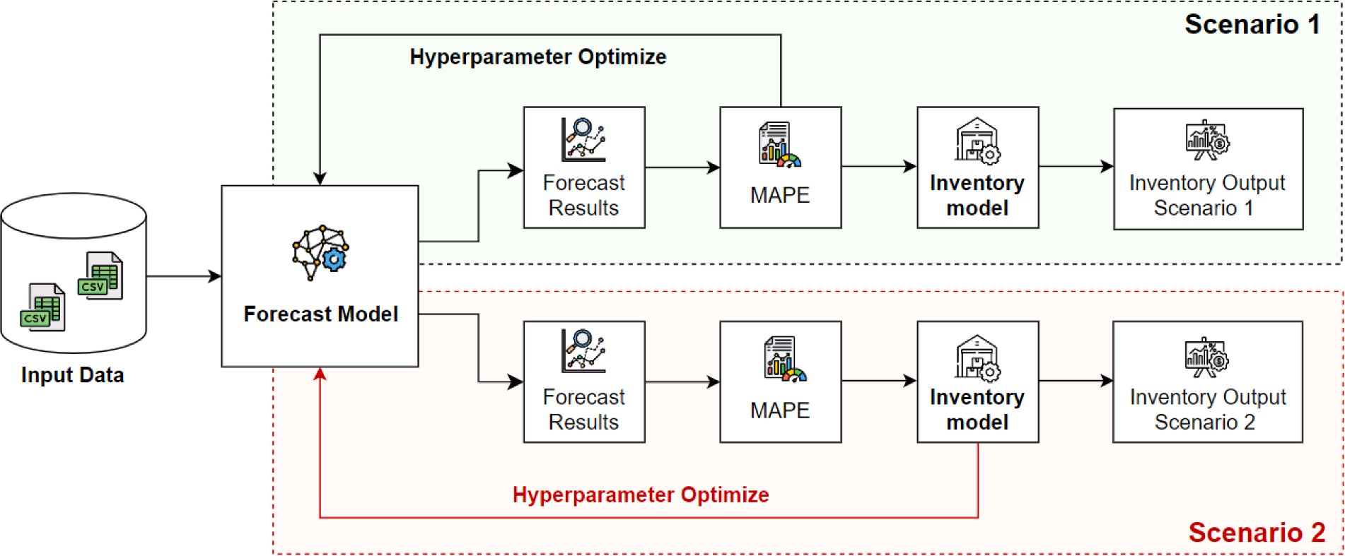
Fig. 1. Overview of the proposed methodology with two scenarios.
In Scenario 1, the forecasting component was evaluated independently to measure its contribution to inventory management. Data collection was initiated by combining internal company data with external crawled data, after which preprocessing was performed. Two forecasting approaches were applied: a standalone TSMixer model and a hybrid RevIN-TSMixer model. Forecast accuracy was evaluated using MSE, MAE, RMSE, and MAPE, with MAPE being treated as the primary metric for comparison across datasets. The resulting forecasts were then combined with historical sales and inventory data and were used as inputs to an inventory model based on the continuous review $\left(r , q\right)$policy, where $r$represented the reorder point and $q$denoted the order quantity. Safety stock, reorder points, and total costs were then computed to analyze how forecasting affected inventory performance under separated evaluation.
In Scenario 2, inventory outcomes were integrated into the evaluation process using an end-to-end viewpoint. The workflow followed the same stages of data collection, preprocessing, and forecasting as in Scenario 1, and the same forecasting models were applied. However, hyperparameter optimization was driven primarily by the Total Cost metric so that the financial consequences of forecasting errors (e.g., overstocking or stockouts) could be captured directly. Because shortage levels were treated as fluctuating, optimization was focused on minimizing Total Cost to adapt to varying demand conditions, while MAPE was retained as a supplementary measure of forecast accuracy. Inventory decisions were generated using the same $\left(r , q\right)$policy, and the integrated framework was used to highlight practical and economic implications of forecasting accuracy in inventory management.

3.2. Demand forecasting

3.2.1. Forecasting problem formulation
A three-month lead time was selected to align demand forecasting with inventory-management requirements. This forecasting cycle was framed as enabling sufficient time for supply and production adjustments and supporting inventory preparation to avoid shortages and excess stock, while also matching typical production and supply cycles.
The forecasting task was formulated as predicting a future time series $\hat{X}$from a historical time series $X$, with the historical series defined over length $S$and feature dimension $C$, and the predicted series defined over $N$forecast steps and $F$predicted features. The formal representation was provided in Eq. (1).
$\begin{matrix} & X=\left[\begin{aligned}X_{1} \\ X_{2} \\ ⋮ \\ X_{S}\end{aligned}\right]=\left[\begin{matrix}X_{1,1} & X_{1,2} & … & X_{1,C} \\ X_{2,1} & X_{2,2} & … & X_{2,C} \\ ⋮ & ⋮ & ⋱ & ⋮ \\ X_{S,1} & X_{S,2} & … & X_{S,C}\end{matrix}\right],\hat{X}=\left[\begin{aligned}{\hat{X}}_{S+4} \\ {\hat{X}}_{S+5} \\ ⋮ \\ {\hat{X}}_{S+N+3}\end{aligned}\right]=\left[\begin{matrix}{\hat{X}}_{S+4,1} & {\hat{X}}_{S+4,2} & … & {\hat{X}}_{S+4,F} \\ {\hat{X}}_{S+5,1} & {\hat{X}}_{S+5,2} & … & {\hat{X}}_{S+5,F} \\ ⋮ & ⋮ & ⋱ & ⋮ \\ {\hat{X}}_{S+N+3,1} & {\hat{X}}_{S+N+3,2} & … & {\hat{X}}_{S+N+3,F}\end{matrix}\right]. & (1) & \end{matrix}$

3.2.2. TSMixer model
The Time-Series Mixer (TSMixer) model was described as an MLP-based forecasting paradigm for multivariate time series, where mixing was performed across temporal and feature dimensions so that trends over time and cross-sectional feature interactions could be captured. The architecture was presented as comprising a Mixing Layer and a Temporal Projection Layer, with the Mixing Layer including a Time-Mixing Layer and a Feature-Mixing Layer that operated sequentially.
The input was defined as a tensor $B^{\left(d\right)}∈R^{M×T×C}$, where $M$denoted batch size, $T$ denoted the number of time steps, and $C$denoted the number of input features. Fig. 2 illustrates the overall architecture of the proposed forecasting framework and shows how the RevIN-TSMixer extends the baseline TSMixer pipeline.
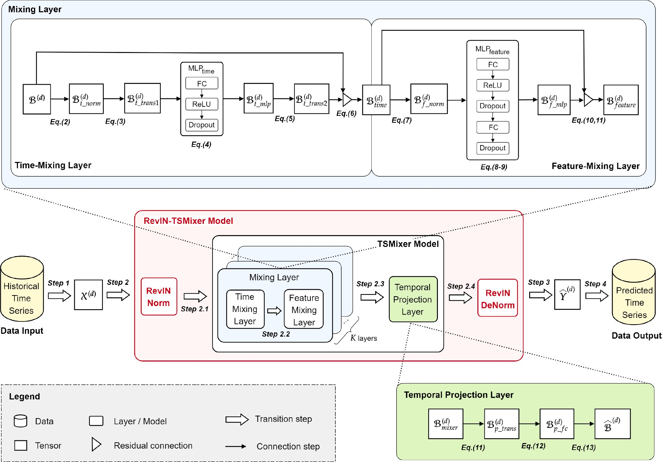
Fig. 2. Overall architecture of the proposed model ( Step 1: divide the input sequence into tensors →Step 2: forecasting model: the RevIN-TSMixer model includes transition steps 2.1 to 2.4, while the TSMixer model includes only steps 2.3 and 2.4 →Step 3: output tensor generated after forecasting →Step 4: combine the tensors to form the final output prediction).
In the Time-Mixing Layer, transformations were applied along the time dimension to capture temporal dependencies. First, 2D batch normalization was applied to stabilize training and improve convergence, and a tensor transpose operation was applied so that the MLP operating across time steps could be used effectively. A linear transformation followed by ReLU and dropout was then applied to perform temporal mixing, after which the tensor was transposed back. A residual connection was then added so that original input information would be preserved and gradient flow would be improved. These operations were formalized in Equations (2)–(6).
$$\begin{matrix} & B_{t_norm}^{\left(d\right)}=2DBatchNorm(B^{\left(d\right)}). & & \text{(2)}\end{matrix}$$
$$\begin{matrix} & B_{t_trans1}^{\left(d\right)}=Tensor_Transpose(B_{t_norm}^{\left(d\right)})∈R^{M×T×N}. & & \text{(3)}\end{matrix}$$
$$\begin{matrix} & B_{t_mlp}^{\left(d\right)}=Dropout(ReLU(B_{t_trans1}^{\left(d\right)}*W_{1}⊕b_{1}), p), & & \text{(4)}\end{matrix}$$
$$\begin{matrix} & B_{t_trans2}^{\left(d\right)}=Tensor_Transpose(B_{t_mlp}^{\left(d\right)})∈R^{M×T×C}. & & \text{(5)}\end{matrix}$$
$$\begin{matrix} & B_{time}^{\left(d\right)}=B_{t_trans2}^{\left(d\right)}+B^{\left(d\right)}∈R^{M×T×C}. & & \text{(6)}\end{matrix}$$
In the Feature-Mixing Layer, cross-variable dependencies were modeled at each time step. The output from the Time-Mixing Layer was first normalized with 2D batch normalization, and then MLP-based feature transformations were applied (including ReLU and dropout). Residual connections were used to mitigate vanishing-gradient behavior and to support deeper architectures, with the residual handling depending on whether the number of predicted features F matched the input feature dimension C. These operations were described through Equations (7)–(10).
$$\begin{matrix} & B_{f_norm}^{\left(d\right)}=2DBatchNorm(B_{time}^{\left(d\right)}). & & \text{(7)}\end{matrix}$$
$$V_{f_mlp}^{\left(d\right)}=Dropout(ReLU(B_{f_norm}^{\left(d\right)}*W_{2}⊕b_{2}), p), \\ \begin{matrix} & B_{f_mlp}^{\left(d\right)}=Dropout(V_{f_mlp}^{\left(d\right)}*W_{3}⊕b_{3}, p), & & \text{(8)}\end{matrix}$$
$$\begin{matrix} & B_{feature}^{\left(d\right)}=B_{f_mlp}^{\left(d\right)}+B_{time}^{\left(d\right)}∈R^{M×T×F}. & & \text{(9)}\end{matrix}$$
$$\begin{matrix} & B_{feature}^{\left(d\right)}=(B_{f_mlp}^{\left(d\right)}*W_{4}⊕b_{4})+B_{time}^{\left(d\right)}∈R^{M×T×F}. & & \text{(10)}\end{matrix}$$
In the Temporal Projection Layer, the representation was projected from the original sequence length T to the forecast length N. This was implemented through a transpose, a fully connected transformation, and a second transpose to recover the desired tensor arrangement for prediction, as described in Equations (11)–(13).
$$\begin{matrix} & B_{p_trans}^{\left(d\right)}=Tensor_Transpose(B_{mixing}^{\left(d\right)})∈R^{M×F×N}. & & \text{(11)}\end{matrix}$$
$$\begin{matrix} & B_{p_fc}^{\left(d\right)}=B_{p_trans}^{\left(d\right)}*W_{4}⊕b_{4}∈R^{M×F×N}. & & \text{(12)}\end{matrix}$$
$$\begin{matrix} & {\hat{B}}^{\left(d\right)}=Tensor_Transpose(B_{p_fc}^{\left(d\right)})∈R^{M×H×F}. & & \text{(13)}\end{matrix}$$The overall TSMixer procedure was summarized by the algorithmic description in Algorithm 1.
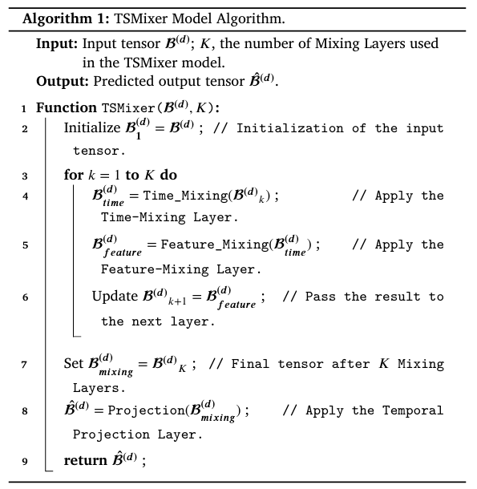

3.2.3. RevIN method
It was noted that distribution shifts (i.e., changes in mean and variance over time) could reduce generalization, especially when training and testing segments differed statistically. The Reversible Instance Normalization (RevIN) method was therefore used as a normalization and inverse-normalization approach tailored to time-series forecasting in order to reduce the effects of distribution shift (Liu et al., 2023).
RevIN normalization was implemented by computing per-instance (and per-feature) mean and variance, followed by normalization and a learned scale-and-shift operation using $γ_{c}$and $β_{c}$, as outlined in Algorithm 2. A small constant $ϵ$was included for numerical stability.
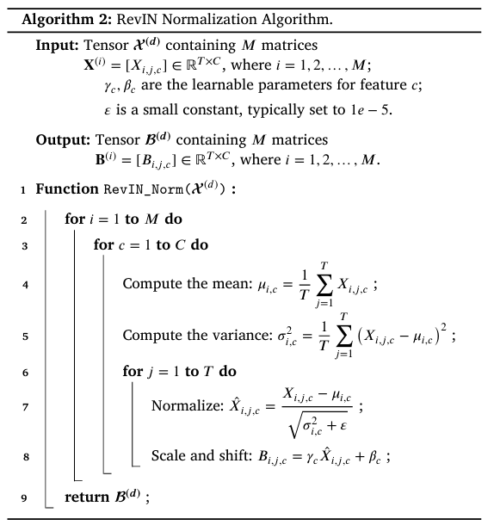
The inverse normalization step was applied to restore the original scale of outputs by reversing the normalization process, thereby maintaining interpretability and consistency of predictions, as summarized in Algorithm 3.
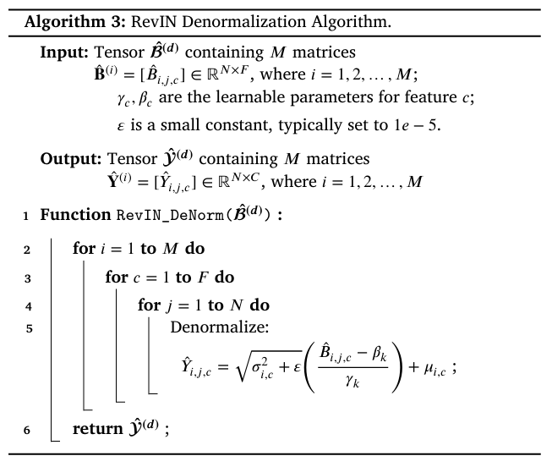

3.2.4. RevIN-TSMixer model
RevIN was integrated as both a preprocessing step (normalizing the input) and a postprocessing step (denormalizing the output) so that the robustness of TSMixer could be enhanced under real-world noise and distributional shifts. The resulting RevIN-TSMixer procedure was expressed as a pipeline in which RevIN normalization was applied first, the TSMixer model was then executed, and RevIN denormalization was finally applied, as summarized in Algorithm 4.
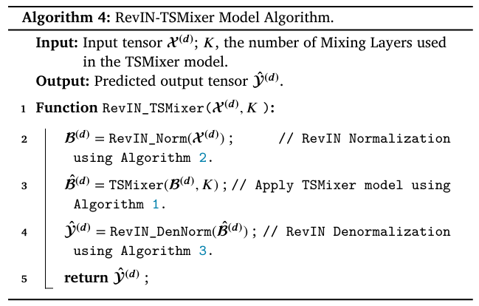
It was argued that this integration supported improved generalization across different time-series distributions while preserving computational efficiency, making the model suitable for complex forecasting settings.

3.3. Probabilistic inventory model
A probabilistic inventory model was applied to handle demand uncertainty, where demand was treated as fluctuating based on forecasted results produced by RevIN-TSMixer.

3.3.1. The continuous review policy $\left(r , q\right)$
A continuous review $\left(r , q\right)$policy was used, where inventory was monitored continuously and replenishment was triggered using the reorder point $r$and the order quantity $q$. The policy was described as reducing stockout risk while avoiding excessive holding costs.
The optimal order quantity and the forecasted demand mean were defined as follows:
$$Q^{*}=\sqrt{\frac{2⋅μ_{D}⋅o}{h}},μ_{D}=\frac{1}{N}⋅\sum_{i=1}^{N}{F_{i}}.$$

3.3.2. Determination of total costs
Inventory-cost minimization was framed as the primary objective, and shortage costs were incorporated in addition to ordering and holding costs so that overstocking and understocking implications could be balanced. Because shortage cost per unit was described as difficult to determine directly, shortages were controlled using a target service level $α$through the stockout probability $P(X≥r)$, as specified in Eq. (14).
$$\begin{matrix} & α=1-P(X≥r)=1-\frac{c_{h}⋅Q^{*}}{c_{s}⋅μ_{D}}, & & \text{(14)}\end{matrix}$$
Based on the service level, safety stock and reorder point were defined as follows.
$$\begin{matrix} & SS=z_{α}⋅σ_{D}⋅\sqrt{L}, & & \text{(15)}\end{matrix} \\ \begin{matrix} & r=μ_{D}⋅L+SS. & & \text{(16)}\end{matrix}$$
Expected shortages and expected shortage costs were determined using a loss function $L(z)$.
$$\begin{matrix} & L(z)=\int_{z}^{∞}{(y-z)⋅ϕ(y) dy,} & & \text{(17)}\end{matrix} \\ \begin{matrix} & E(S)=L(z)⋅σ_{D}⋅\sqrt{L}, & & \text{(18)}\end{matrix} \\ \begin{matrix} & E(c_{s})=\frac{c_{s}⋅E(S)⋅μ_{D}}{Q^{*}}. & & \text{(19)}\end{matrix}$$
Total cost was defined as the sum of ordering cost, holding cost, and expected shortage cost.
$$\begin{matrix} & c_{o}=\frac{μ_{D}}{Q^{*}}⋅o, & & \text{(20)}\end{matrix} \\ \begin{matrix} & c_{h}=\left(\frac{Q^{*}}{2}+max⁡(SS,0)\right)⋅h, & & \text{(21)}\end{matrix} \\ \begin{matrix} & TC=c_{o}+c_{h}+E(c_{s}). & & \text{(22)}\end{matrix}$$
It was emphasized that the $max⁡(SS,0)$term ensured that only positive safety stock contributed to holding cost calculations.
Finally, it was stated that, by combining ordering, holding, and shortage costs through a service-level-driven framework, a comprehensive approach to inventory optimization was obtained that balanced cost efficiency with service requirements while maintaining sufficient inventory to meet demand. The forecasting model was then integrated with the inventory model, and the effectiveness of this integration was evaluated under the two scenarios introduced in Section 3.1, with the integration process being illustrated in Fig. 3.
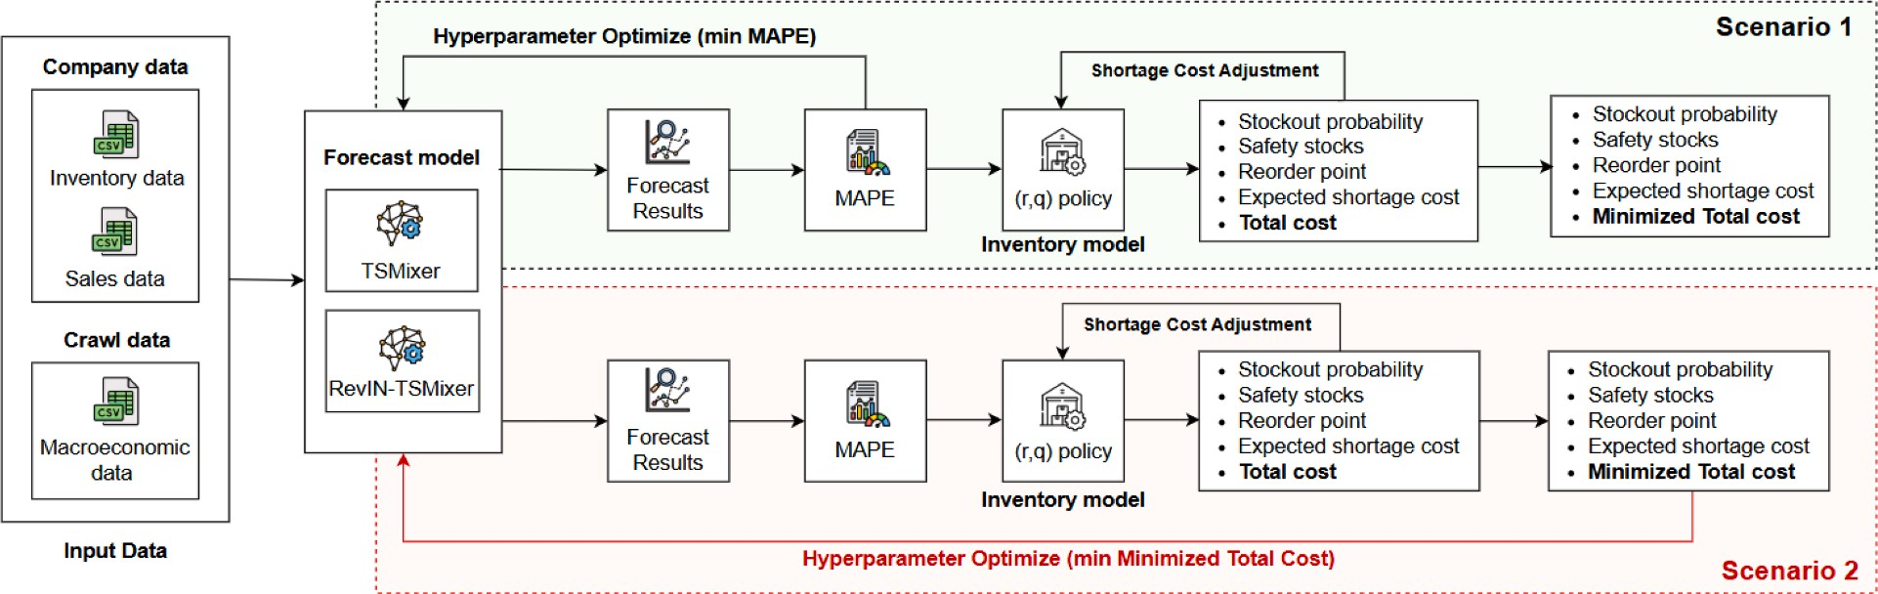
Fig. 3. The process of integrating forecast model and inventory model within these two scenarios.

4. Data Summary
The table below consolidates the key characteristics of the dataset and preprocessing choices used in the study. Collectively, it clarifies what data were used, how they were structured and split for modeling, and which statistical checks and feature-selection steps were applied to ensure that forecasting and inventory-policy evaluation were grounded in an appropriate empirical setup.
Table 1. Summary of Dataset Characteristics and Preprocessing Design
Item | Summary
Context & source | Data from a logistics-sector manufacturing company in Vietnam, combined with external macroeconomic indicators
Period & frequency | Monthly data, Jan 2015 to Dec 2024 (120 months)
Dataset size | 120 observations; 12 total features (internal + macroeconomic)
Target variable | Quantity (product demand)
Example internal features | CompetitorQuantity, PromotionAmount
Example macroeconomic features | Imports, CPI, IPI, DisbursedFDI, RetailSales
Train/val/test split | 80/10/10 chronological split
Normality check (demand) | K–S test p-value = 0.1742 (> 0.05) → normality not rejected; supports normal-based service-level calculations
Feature selection methods | Random Forest and XGBoost feature importance (averaged)
Selected features (predictors) | Imports, IPI, DisbursedFDI, CompetitorQuantity, PromotionAmount (target: Quantity)

5. Answers to Research Questions
This section consolidates the empirical findings by answering each research question in a decision-oriented manner. Collectively, the responses clarify (i) whether RevIN-based forecasting improvements translate into measurable gains over standard TSMixer and baseline deep-learning models, (ii) how conclusions change when model selection is driven by forecast error versus total inventory cost, and (iii) how shortage-cost variation propagates through inventory-policy parameters and cost components. In doing so, the joint forecasting–inventory framework is interpreted not only in terms of predictive accuracy, but also in terms of service-level behavior and total-cost efficiency across the two experimental scenarios.
RQ1: Forecasting accuracy in Scenario 1
Under the error-optimization setting, forecasting performance was reported to be strongest for RevIN-TSMixer relative to TSMixer and the baseline deep-learning models. Substantially improved train/test error behavior was described for RevIN-TSMixer across both experimental scenarios, with test-set error indicators (e.g., MSE/MAE) reported as markedly lower than those of TSMixer. In the dedicated error-optimization comparison, the lowest MAPE among the evaluated models was attributed to RevIN-TSMixer when contrasted with TSMixer, LSTM, GRU, and DNN. The observed improvement was interpreted as being driven by the RevIN mechanism, through which instance-wise stabilization of mean and variance was applied to mitigate distribution shift and thereby improve generalization under non-stationarity and seasonal effects (Liu et al., 2023).
RQ2: Cost optimization may reduce total cost even with worse accuracy
When the optimization target was shifted from forecast error to total inventory cost (Scenario 2), lower minimized total cost values were reported for multiple models relative to the error-optimized regime, even when forecasting accuracy metrics were not improved and were sometimes weakened. This pattern was treated as evidence that the operational objective (inventory cost) may not be well-served by tuning solely for symmetric error metrics, and that end-objective optimization can yield economically preferable policies despite modest deterioration in classical forecasting scores (Kourentzes et al., 2020). The cross-scenario comparison was presented as showing that cost-aware tuning can reduce the achieved minimum total cost at an optimal shortage-cost setting for several models.

RQ3: Effect of shortage cost on inventory metrics
Inventory outcomes were described as exhibiting the expected sensitivity to shortage-cost variation. As shortage cost increased, the stockout probability was reported to decline, consistent with more conservative replenishment behavior under larger penalties. In parallel, both safety stock and reorder point were reported to increase with shortage cost, reflecting the buffering required to meet higher service targets. Expected shortage-cost behavior was described as being shaped by these compensatory system adjustments, while the total cost curve was characterized as exhibiting a U-shaped relationship with shortage cost, indicating the existence of an interior optimum where ordering/holding costs and shortage-related penalties were balanced.
RQ4: Scenario 2 produces clearer inventory-performance separation
Under sequential evaluation (Scenario 1), model-to-model differences in inventory metrics were described as becoming less distinguishable at higher shortage-cost settings, where conservative policies tend to dominate and compress variability across forecasts. By contrast, under cost-aware tuning (Scenario 2), clearer separation was reported both relative to the actual-demand benchmark and across models—particularly in total cost behavior at higher shortage costs—supporting the methodological value of integrating inventory objectives directly into the forecasting optimization process rather than treating inventory evaluation as a post hoc step.
RQ5: RevIN-TSMixer robustness across scenarios
Across both scenarios, RevIN-TSMixer was reported to remain consistently strong from an operational perspective. Low total costs and reduced stockout probability were described relative to alternative models under varying shortage-cost settings, indicating that the RevIN-enhanced forecaster maintained favorable performance when the objective emphasized forecasting accuracy as well as when the objective emphasized cost efficiency. This cross-scenario stability was interpreted as evidence of robustness in balancing predictive accuracy and inventory cost performance.

6. Future Research Directions
Several limitations of the current study point to concrete directions for subsequent research. First, external validity remains constrained because the evaluation was conducted on a single-product dataset drawn from one firm within a single national context; broader generalizability would be strengthened by replication across multi-product portfolios and heterogeneous industries, where demand dynamics, substitution effects, and operational constraints differ materially. Second, cost modeling realism can be improved, since holding and ordering costs were treated as fixed parameters; in operational settings, these costs can vary over time due to storage-capacity constraints, financing conditions, supplier pricing, inflation, and logistics volatility, and more adaptive formulations would therefore be required to represent time-varying cost regimes. Third, important operational and disruption-related drivers were not explicitly incorporated. Although macroeconomic and internal business variables were used, abrupt market or policy shocks and supply-side uncertainties—such as inventory-history effects, delivery-time variability, and delayed shipments—were not modeled, even though they can dominate performance during periods of disruption. Finally, methodological extensions were suggested to better handle non-stationarity and shocks, including the integration of more adaptive decision frameworks such as reinforcement learning or hybrid forecasting–control approaches, and the systematic stress-testing of the forecasting–inventory pipeline under major volatility events to evaluate robustness and failure modes in extreme conditions.

7. Implementation in the Context of Bangladesh

7.1. Purpose and positioning of this section
This section was written to translate the paper’s forecasting–inventory integration concept into a Bangladesh deployment that remains decision-relevant under local volatility, data constraints, and operational frictions (Goltsos et al., 2022; Kourentzes et al., 2020). The central premise of the original framework—that forecasting should be evaluated not only by symmetric error metrics but also by inventory outcomes—was retained (Strijbosch & Moors, 2005), and the same two-scenario logic (error optimization vs total-cost optimization) was adopted as the backbone of implementation (Kourentzes & Barrow, 2020). However, the implementation was redesigned so that Bangladesh-specific drivers that typically dominate inventory performance—especially lead-time variability, event-driven demand shifts, and incomplete retail digitization—were treated as first-class modeling objects rather than nuisances to be averaged out (Gupta, 2020; Hasan & Ali, 2019).

7.2. Why Bangladesh is not “Vietnam with different numbers”
A direct “lift-and-shift” of the paper’s setup into Bangladesh would likely produce inflated confidence in forecast accuracy and fragile inventory recommendations (Kourentzes et al., 2020; Tratar, 2010). Three Bangladesh realities tend to break the implicit assumptions that made the Vietnam case comparatively stable, and each of these realities must be addressed explicitly (Kourentzes et al., 2020; Goltsos et al., 2022).

7.2.1. Lead-time volatility tends to dominate inventory error
In the paper, the continuous-review $\left(r , q\right)$policy was built around a lead time parameter $L$(in months) and service-level logic that converts demand uncertainty into safety stock and reorder point (Winston, 2022; Zuo-Jun Max Shen, 2019). The structural problem in Bangladesh is that lead time often behaves as a non-stationary random variable rather than a stable constant, due to port congestion, customs clearance variability, inland transport bottlenecks (Ahmed & Jahan, 2022; Zaman & Solesvik, 2016), and episodic disruptions (Winston, 2022). When lead time becomes volatile, the reorder point $r$stops being mainly a function of demand uncertainty and becomes primarily a function of lead-time uncertainty (Babai, 2022; Prak, 2021). In practical terms, a model that forecasts demand well but assumes a fixed $L$will still recommend reorder points that are systematically too low during congestion regimes and excessively high during recovery regimes. Therefore, lead-time modeling cannot be treated as a “minor refinement”; it must be integrated into the policy layer and, ideally, into the forecasting features as well (Winston, 2022; Kourentzes et al., 2020).

7.2.2. Demand is event-driven and calendar-shocked
Bangladesh demand often exhibits structural pulses that are concentrated around predictable but intense events like Ramadan and Eid (Al-Ababneh, 2020), as well as seasonal and operational shocks (monsoon effects, exam seasons, political disruptions, and supply interruptions) (M. M. Hossain, 2018; Snyder, 2012). In such settings, distribution shift becomes persistent rather than occasional (Liu et al., 2023). The paper’s motivation for RevIN explicitly highlighted that mean and variance can vary over time and that such distribution shift can degrade generalization, which makes RevIN conceptually aligned with Bangladesh conditions (Kim, 2021). However, it must also be recognized that normalization alone does not encode the causal structure of events; it stabilizes scale, but it does not “know” why a spike occurs (M. S. Hossain & Khan, 2021). As a result, explicit event features and event-window evaluation must be added; otherwise, the model may achieve acceptable overall metrics while failing precisely where inventory pain is largest—during event periods when stockouts and emergency replenishment costs explode (Kourentzes et al., 2020; Winston, 2022).

7.2.3. Data coverage and quality are uneven by design
A large fraction of Bangladesh retail remains partially digitized (Bank, 2023), with varying data fidelity across channels, geographies, and product families. As a result, “adding more macro features” will not automatically compensate for missing point-of-sale coverage, late reporting, or inconsistent SKU mapping (Akter, 2016). A data acquisition and governance plan must be embedded in the implementation blueprint, because model performance will be constrained by what is measured consistently (Goltsos et al., 2022). In other words, the core technical contribution of the paper—the integration of demand forecasting with inventory optimization—must be complemented in Bangladesh by a practical operational contribution: a pathway to obtain reliable demand, promotion, competitor, and lead-time signals at usable granularity (Quader & Abdullah, 2017).

7.3. Bangladesh use case: FMCG distribution (Dhaka–Chattogram corridor)

7.3.1. Target industry and operational structure
A realistic and high-value Bangladesh deployment candidate is an FMCG distributor serving Dhaka metro and regional hubs, with inbound flows that are materially influenced by Chattogram logistics (Heese, 2007). The corridor is strategically appropriate because it is where the most visible interactions between demand shocks (consumer purchasing patterns) and operational shocks (port and transport variability) are observed (Winston, 2022).

7.3.2. Why FMCG fits the paper’s framework
FMCG distribution fits the paper’s architecture for three reasons (Goltsos et al., 2022; Kourentzes et al., 2020):
- Demand forecasting naturally informs replenishment planning, either at monthly planning cadence (procurement and import planning) or weekly cadence (distribution and replenishment) (Syntetos et al., 2009; Goltsos et al., 2022).
- Stockouts have interpretable shortage costs: immediate lost sales, retailer switching to competitor brands, and sometimes shelf-space penalties or reduced visibility—costs that map directly to the shortage-cost-driven inventory model emphasized in the paper (Winston, 2022; Zuo-Jun Max Shen, 2019).
- Promotions and competitor activity strongly influence demand, consistent with the original dataset’s inclusion of promotional spending and competitor demand indicators, and consistent with the broader argument that forecasting should be aligned to downstream inventory objectives rather than only to average-fit error (Kourentzes et al., 2020; Tratar, 2010; Gneiting, 2011).

7.3.3. Practical unit of analysis
The initial unit of analysis should be selected so that data integrity is maximized while business value remains visible (Goltsos et al., 2022). SKU-level forecasting is often desired but rarely feasible immediately. Therefore, a staged approach is recommended: (i) category or brand-family level for the initial pilot, (ii) top SKUs (A-class) as data stabilizes, and (iii) tail SKUs only after governance and automation mature (Goltsos et al., 2022).

7.4. Data modifications (Bangladesh-specific): designing a feature set that survives shocks
The paper used internal variables and macro indicators to forecast demand and then linked forecasts to inventory decisions (Goltsos et al., 2022; Kourentzes et al., 2020). A Bangladesh implementation should preservsae this internal+macro scaffold but must be extended with (i) event shock structure and (ii) lead-time/fulfillment uncertainty (Kourentzes et al., 2020; Liu et al., 2023; Winston, 2022). Table 2 summarizes an illustrative dataset schema for the Bangladesh implementation of the proposed forecasting and inventory framework. The structure is designed to align with the study’s internal and macro-level modeling logic while extending it with country-relevant event and operational lead-time variables to better reflect real-world uncertainty in Bangladesh’s supply chain environment.
Table 2. Illustrative Bangladesh Implementation Dataset Structure for Demand Forecasting and Inventory Optimization
Data Block | Variable | Definition | Granularity | Frequency | Example Unit | Likely Source | Why it matters (Bangladesh deployment)
Target | Quantity | Demand (sell-out if available; otherwise sell-in to retailers) | Category / Brand-family (pilot) | Monthly (pilot), Weekly (later) | units/cases | ERP/Sales ledger | Primary forecasting target used for inventory decisions
Internal (Commercial) | PromotionAmount | Total promo spend for the category in period | Category / Region | Monthly/Weekly | BDT | Marketing + Finance | Promo-driven demand spikes must be explained, not normalized away
Internal (Commercial) | PromoFlag | 1 if major promo active (discount/bundle/display), else 0 | Category / Region | Weekly | binary | Trade marketing calendar | Captures discrete events that spending alone may not reflect
Internal (Commercial) | PriceIndex_own | Own-brand price index relative to baseline | Category | Monthly | index | Pricing/Finance | Demand sensitivity to price increases during inflation/FX stress
Internal (Commercial) | CompetitorQuantityProxy | Proxy for competitor demand (survey/retailer feedback/market intel) | Category / Region | Monthly | index | Sales field reports / panels | Mirrors “competitor quantity” concept when competitor sales are not observed
Internal (Commercial) | CompetitorPromoIntensity | Competitor promotion intensity proxy | Category / Region | Weekly | index | Sales intel / retailer audits | Explains share shifts and unexpected demand drops
Internal (Channel/Distribution) | OutletCoverage | # active outlets served (or % of target outlets) | Region | Monthly | count/% | Sales ops | Controls for distribution expansion/contraction masquerading as demand
 | FillRate | Delivered quantity / ordered quantity | Category / Region | Monthly/Weekly | % | Warehouse + delivery records | Low fill rate censors observed sales and biases “demand” downward
Macro & Market | CPI_Food | CPI sub-index relevant to FMCG basket | National | Monthly | index | National statistics | Purchasing power and substitution behavior
Macro & Market | ExchangeRate_USDBDT | Average monthly FX | National | Monthly | BDT/USD | Central bank/public data | FX pass-through affects imported inputs and retail pricing
Macro & Market | ImportsValue_FMCG | Import value/volume for relevant product/input class | National | Monthly | BDT/tons | Trade/NBR stats | Captures supply tightness and price shocks
Macro & Market | IPI | Industrial Production Index (proxy for economic activity) | National | Monthly | index | Official macro series | Macro demand environment (paper uses IPI-style drivers)
Macro & Market | DieselPrice | Retail diesel price | National | Monthly/Weekly | BDT/L | Energy regulator/public | Transport cost shocks affect distribution + retail prices
Events & Calendar (Bangladesh-specific) | RamadanFlag | 1 during Ramadan window | National | Weekly | binary | Calendar | Structural demand shifts; must be encoded explicitly
Events & Calendar (Bangladesh-specific) | EidFlag | 1 during Eid window (pre/post buffer) | National | Weekly | binary | Calendar | Peak demand + stockout risk; key evaluation window
Events & Calendar (Bangladesh-specific) | HolidayCount | Number of national holidays in period | National | Monthly | count | Calendar | Drives shopping patterns + logistics closures
Events & Calendar (Bangladesh-specific) | ExamSeasonFlag | 1 during major exam windows | National | Weekly | binary | Academic calendar | Shifts consumption patterns for specific FMCG categories
Events & Calendar (Bangladesh-specific) | MonsoonRainIndex | Rainfall/monsoon intensity proxy | Region | Weekly/Monthly | index/mm | Weather data | Affects both consumption and delivery reliability
Operational (Lead-time & Logistics) | LeadTimeDays | Order placement to delivery receipt time | Lane (CTG→Dhaka, Dhaka→Hub) | Per shipment (aggregated weekly/monthly) | days | TMS/Delivery logs | Bangladesh-critical: lead-time volatility drives reorder point error
Operational (Lead-time & Logistics) | LeadTimeP90 | 90th percentile lead time in the period | Lane | Monthly | days | Derived from LeadTimeDays | Supports quantile-based reorder point logic
Operational (Lead-time & Logistics) | DelayFlag | 1 if shipment delay occurred | Lane | Per shipment | binary | Logistics notes | Helps separate demand failure from fulfillment failure
Operational (Lead-time & Logistics) | CustomsClearanceDays | Clearance duration for imported items (if applicable) | Port/import batch | Per batch | days | Import docs | Captures port/customs regime shifts
Operational (Lead-time & Logistics) | StockoutDays | Days out-of-stock in period | SKU/Category + Region | Weekly/Monthly | days | Inventory system/field logs | Directly links forecasting errors to service-level outcomes
Operational (Lead-time & Logistics) | BackorderDays | Days demand was backordered (if allowed) | SKU/Category + Region | Weekly/Monthly | days | Order management | Distinguishes lost sales vs delayed fulfillment
Inventory State (recommended add-on) | OnHandInventory | End-of-period on-hand inventory | SKU/Category + DC | Weekly/Monthly | units | WMS/ERP | Needed for decision support + for diagnosing censored demand
Inventory State (recommended add-on) | OpenPO | Outstanding purchase orders not yet received | SKU/Category | Weekly/Monthly | units | Procurement | Prevents double-ordering; critical with volatile lead time

7.4.1. Internal (firm-level) demand and commercial drivers
A Bangladesh-compatible “internal” feature block should include (Goltsos et al., 2022):
- Sales quantity at the chosen aggregation level (brand/category initially), with a disciplined approach to returns, replacements, and channel mix so that the demand signal is not contaminated by accounting artifacts (Goltsos et al., 2022).
- Promotion spend and promo calendar, structured as both numeric spend and categorical flags (promo type, depth of discount, bundle vs price cut, and geographic targeting). This mirrors the paper’s internal promotional variable structure and maintains comparability across scenarios (Kourentzes et al., 2020).
- Competitor proxies, which must be pragmatic rather than idealized. If direct competitor sales are unavailable, proxies can be formed using competitor price indices, competitor promo intensity, retailer surveys, and distributor intelligence signals. A formal “competitor demand” variable is rarely observed in Bangladesh; therefore, a robust proxy engineering plan should be treated as part of deployment design, not as optional embellishment (Goltsos et al., 2022).

7.4.2. Macro and market context (Bangladesh)
The paper’s macroeconomic feature set included indicators such as CPI, imports, industrial production, FDI, and retail sales, which were introduced as contextual drivers of demand variation (Goltssos et al., 2022). For Bangladesh, these equivalents should be mapped and extended with additional stressors that are more operationally material to the local context (Goltssos et al., 2022). In particular, trade-related foreign exchange stress should be incorporated through variables such as exchange rate movements, import volume or value, and container-throughput proxies, since FX pass-through often affects pricing and purchasing power rapidly (Goltssos et al., 2022). Inflation and household purchasing power should also be captured more explicitly through CPI sub-indices, such as food versus non-food inflation, together with wage proxies (Goltssos et al., 2022).
In addition, energy and transportation cost variables, including diesel price and freight cost indices, should be included because they influence both distribution expenses and retail pricing sensitivity (Winston, 2022). Seasonality must also be represented more carefully through engineered features for Ramadan and Eid, major holidays, school examination periods, wedding season proxies, and month-of-year indicators, as these effects are often more pronounced in Bangladesh than in aggregate macroeconomic series (Liu et al., 2023). Weather-related variation is another critical factor; rainfall proxies and flood indicators should be incorporated because distribution feasibility and consumption patterns can be weather-linked in ways that aggregate macro indicators do not capture well (Goltssos et al., 2022). Finally, disruption-sensitive indicators such as hartal or shutdown proxies, political instability markers, and major policy announcements related to import restrictions or VAT changes should be considered, since these events can materially affect both supply continuity and market demand in Bangladesh (Goltssos et al., 2022).

7.4.3. Operational and lead-time data
The paper acknowledged important limitations arising from the omission of operational variables such as inventory history, uncertain delivery time, and delayed shipments (Kourentzes et al., 2020). In the Bangladesh context, this limitation should be addressed in the first production-ready version of the framework, because operational frictions are not peripheral but central to forecasting and inventory performance (Kourentzes et al., 2020). At a minimum, the implementation should include operational block variables such as order-to-delivery lead-time history by lane, for example from Chattogram to Dhaka and from Dhaka to district hubs, with timestamped order placement and receipt records so that delivery variability can be learned directly from the data (Winston, 2022).
The model should also capture shipment-delay flags and associated reason codes whenever available, including customs issues, carrier failures, congestion, weather disruptions, and labor-related interruptions, because these signals provide a more realistic basis for inventory-policy decisions under uncertainty (Winston, 2022). Stockout logs should be incorporated as well, including stockout duration and lost-sales estimation or suitable proxies, since observed demand can otherwise be systematically censored during periods of unavailability (Winston, 2022). Where backordering is permitted in parts of the network, backorder behavior should also be recorded, because demand may be deferred rather than lost, and service-level computation becomes highly sensitive to whether unmet demand is postponed or permanently foregone (Winston, 2022).

7.5. Model modifications: making RevIN-TSMixer decision-stable in Bangladesh
The paper motivated RevIN as a mechanism to mitigate distribution shift by stabilizing mean and variance across time series instances and integrated it as preprocessing and postprocessing around TSMixer to improve robustness (Chen, 2023; Kim, 2021).In Bangladesh, the same logic should be retained, but three additional modeling decisions should be made to ensure operational reliability (Kourentzes et al., 2020).

7.5.1. Missingness should be handled intentionally
A missing-data policy should be specified at the outset because an inappropriate imputation strategy can suppress true event spikes and introduce artificial smoothness into the series, thereby distorting both forecasting and inventory analysis (Liu et al., 2023). When POS coverage is incomplete, hierarchical aggregation should be adopted so that the data can be structured from SKU to brand to category, with model training initiated at the highest level that remains consistently measured (Goltssos et al., 2022). This allows the implementation to preserve reliability in the presence of partial observability rather than forcing unstable low-level estimates.
At the same time, forward-fill should not be used as a default strategy in event-driven series, because it tends to smear short-lived shocks and create artificial persistence that can mislead both demand forecasting and inventory calculations (Liu et al., 2023). Model-based imputation should likewise be applied only when supported by a stable covariate structure; otherwise, the imputation model itself becomes a hidden source of error and may later be mistaken for forecasting failure when inventory outcomes deteriorate (Liu et al., 2023).

7.5.2. Event-aware inputs must be added, and evaluation must be split by event windows
RevIN can stabilize scale, but event causality must be represented explicitly (Liu et al., 2023). Therefore, calendar and shock features should be injected into the multivariate input so that the model can condition predictions on known event structure (Liu et al., 2023). Two evaluation regimes should be run continuously (Kourentzes et al., 2020):
- Overall performance, to track baseline quality (Gneiting, 2011).
- Event-window performance, such as 6–10 weeks around Ramadan/Eid, to measure whether the model succeeds at the business-critical moments (Kourentzes et al., 2020; Winston, 2022).
This split is aligned with the paper’s core warning that the most accurate forecast by standard metrics does not necessarily yield optimal inventory performance, because event windows tend to be where asymmetric costs are largest (Kourentzes et al., 2020; Tratar, 2010; Gneiting, 2011).

7.5.3. A two-stage training and selection strategy should be institutionalized
The paper’s two-scenario framing provides a natural blueprint: error optimization (Scenario 1) vs cost optimization (Scenario 2) (Kourentzes et al., 2020). In Bangladesh, a two-stage deployment should be implemented (Kourentzes et al., 2020):
- Stage 1 (forecast competence): a RevIN-TSMixer model should be trained and validated with standard error metrics to establish baseline credibility and detect data pipeline issues early (Gneiting, 2011).
- Stage 2 (decision competence): hyperparameters should be tuned using Total Cost as the primary objective, reflecting the paper’s integration of inventory outcomes into forecasting optimization (Kourentzes et al., 2020; Tratar, 2010).
This structure is essential because, in Bangladesh FMCG, the operational penalty is usually not “slightly higher MAPE”; it is the combination of stockout losses and lead-time surprises that compound during peak demand and disruption periods (Winston, 2022).

7.6. Inventory modifications: adapting the $\left(r , q\right)$policy to Bangladesh operational risk
The paper used a continuous review $\left(r , q\right)$policy and tied service level and safety stock to shortage-cost-driven logic (Winston, 2022; Zuo-Jun Max Shen, 2019). That policy remains appropriate in Bangladesh, but three upgrades are required for realism and robustness.

7.6.1. Lead time should be treated as variable
The paper defined lead time $L$in months as a policy parameter within the inventory model (Winston, 2022). In Bangladesh, lead time should be operationalized as a distribution and incorporated into reorder logic. A practical adaptation is recommended:
- Quantile-based effective lead time should be used. Instead of a single $L$, an “effective $L$” can be computed as the 80th–95th percentile of lane-specific lead times during the relevant regime.
- Regime segmentation should be applied when lead time changes structurally (e.g., pre- vs post-disruption). If a single distribution is used across regimes, reorder points will be systematically biased.
This upgrade directly addresses the paper’s limitation statement that uncertain delivery time and delayed shipments were not incorporated in the original forecasting model (Kourentzes et al., 2020).

7.6.2. Shortage cost estimation should be operationalized
The paper treated shortage cost as a core decision variable and emphasized that it directly shapes other inventory metrics, including stockout probability, safety stock, reorder point, and total cost (Winston, 2022; Zuo-Jun Max Shen, 2019). In the Bangladesh FMCG context, shortage cost per unit should therefore be estimated through a finance-credible decomposition rather than assigned as a purely notional parameter. A practical specification would include the gross margin lost on stockout volume, since each missed sale has an immediate contribution impact. It should also incorporate switching probability, or brand substitution behavior, estimated from historical post-stockout sales patterns or retailer-survey proxies, because some unmet demand will migrate to competing products rather than disappear uniformly (Winston, 2022).
Where applicable, the shortage-cost framework should further account for retailer penalties or shelf-space loss in modern trade settings, as these effects can create longer-run commercial damage beyond the immediate lost transaction. In addition, emergency replenishment premiums should be included to capture the incremental cost of expedited transport, overtime, and spot procurement that often arise when firms try to recover from stockout situations under time pressure (Winston, 2022). Because the paper also stressed that asymmetric overstocking and understocking costs are central to inventory decisions, while standard forecast error metrics do not capture that asymmetry, shortage-cost estimation should be treated as a governance artifact jointly owned by supply chain, sales, and finance rather than as a modeling placeholder chosen in isolation (Kourentzes et al., 2020; Gneiting, 2011).

7.6.3. Service-level targets should be segmented (not uniform)
A single service level across all items is typically suboptimal in Bangladesh because working capital constraints and demand volatility vary sharply by SKU class. A segmentation scheme should be implemented (Winston, 2022):
- A-class (high velocity/high margin/high strategic): higher service levels and stronger protection during events.
- B-class: moderate service levels, with tighter capital discipline.
- C-class (long tail): lower service levels, with more reliance on substitution or make-to-availability.
This design is aligned with the paper’s broader message that the most accurate forecast does not necessarily optimize inventory and that decision objectives should be aligned with costs and service priorities rather than average-fit metrics (Kourentzes et al., 2020; Tratar, 2010; Gneiting, 2011).

7.7. Realistic Bangladesh implementation plan (end-to-end)
A staged implementation plan is recommended to reduce deployment risk and ensure that learning is institutionalized through measurable outcomes and governance controls (Goltsos et al., 2022). The objective is to deliver a pilot that is operationally credible, used in planning decisions, and evaluable using both forecasting accuracy and inventory cost/service metrics, consistent with the forecasting–inventory integration rationale (Kourentzes et al., 2020; Winston, 2022). To make the deployment logic implementation-ready, Fig. 4. summarizes the Bangladesh-adapted end-to-end pipeline from scoping through monitoring, and Algorithm 5a–Algorithm 5b formalize the operational steps.
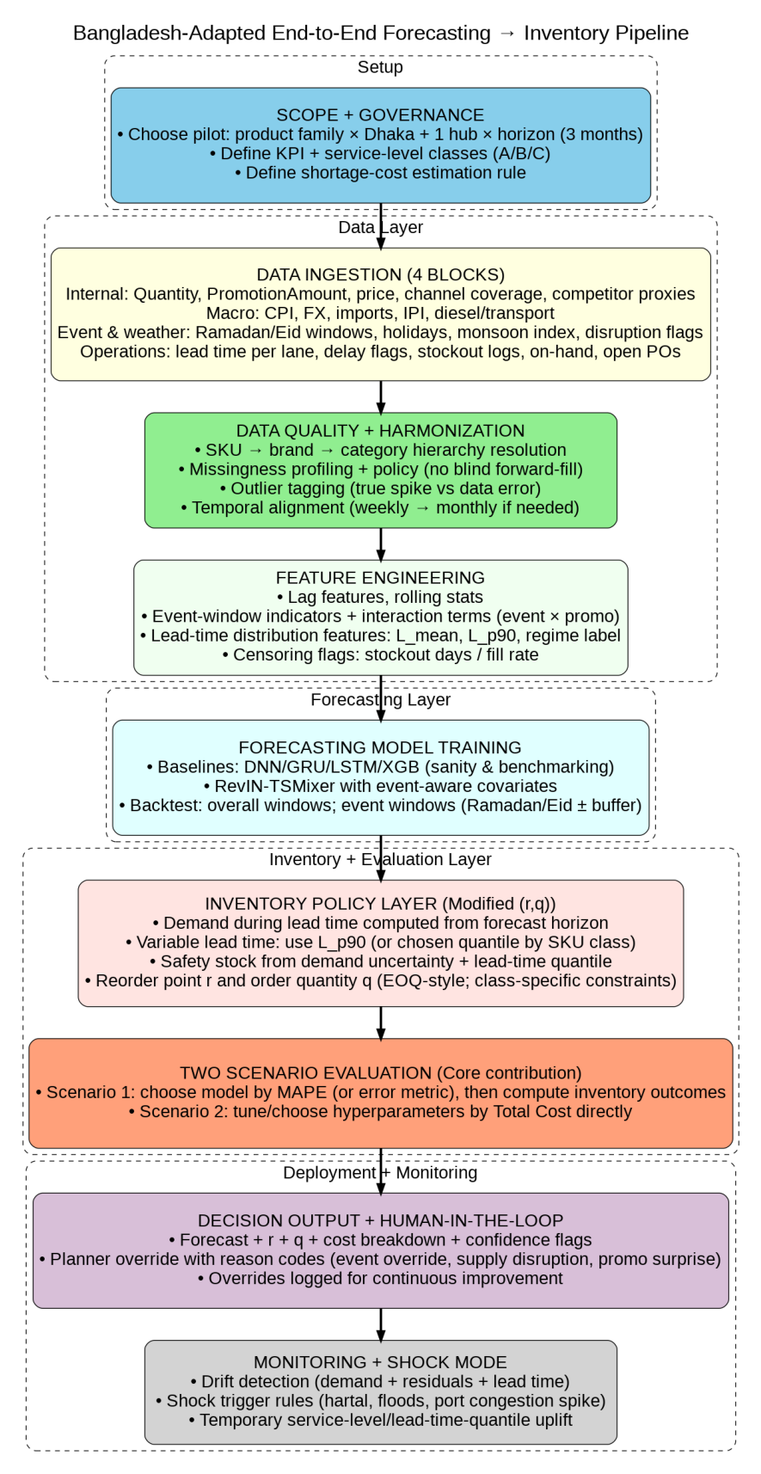
Fig. 4. Bangladesh-Adapted End-to-End Forecasting $→$ Inventory Pipeline.
Fig. 4 also makes explicit the two evaluation regimes—error optimization (Scenario 1) versus total-cost optimization (Scenario 2)—that are central to aligning forecasting with inventory outcomes (Kourentzes et al., 2020; Tratar, 2010; Gneiting, 2011). Algorithm 5a specifies the training, selection, and inventory computation workflow (Phases 1–5), while Algorithm 5b specifies monitoring, drift detection, and shock-mode control (Phase 6), ensuring robustness under regime shifts and disruption events.
Algorithm 5a: Bangladesh-adapted RevIN-TSMixer with variable lead-time $\left(r , q\right)$optimization (Phases 1–5)
Input: historical demand $y_{1:T}$; covariates $X_{1:T}$(internal, macro, event/weather, operational); lane-wise lead-time history $LT$; costs $o$(ordering), $h$(holding); shortage-cost rule $c_{s}$or service-level mapping $α(⋅)$; SKU class $Class∈\{A,B,C\}$; lead-time quantile map $q_{L}(Class)$; forecast horizon $H$.
Output: forecast ${\hat{y}}_{T+1:T+H}$; effective lead time $L^{\text{*}}$; safety stock $SS$, reorder point $r$, order quantity $q$; total cost $TC$; monitoring flags.
Phase 1: Data preparation and governance
- Hierarchy is resolved (SKU $→$brand $→$category) and timestamps are aligned across all sources.
- Missingness is profiled; censored periods (stockouts, low fill-rate) are tagged; anomalies are detected and labeled as true spikes vs data errors.
- If SKU-level reliability is sufficient, modeling is performed at SKU level (A-class prioritized). Otherwise, data are aggregated to the most reliable level (brand/category) and modeling proceeds at that level.
Phase 2: Feature engineering
4. Lag and rolling features are constructed for demand and covariates.
5. Event features are constructed (Ramadan/Eid windows, holidays, monsoon index, disruption flags).
6. Operational features are constructed (stockout days, fill-rate, on-hand inventory, open POs, delay flags).
7. Lane-wise lead-time distributions are computed and the effective lead time is set using the class-specific quantile:
$$L^{\text{*}}←Quantile(LT, q_{L}(Class)).$$
Phase 3: Forecast model training and backtesting
8. Baseline models (e.g., DNN/GRU/LSTM/XGB) are trained for benchmarking.
9. TSMixer and RevIN-TSMixer are trained using multivariate inputs $X_{1:T}$.
10. Backtesting is performed on (i) overall windows and (ii) event windows (Ramadan/Eid $±$buffer).
Phase 4: Two-regime selection
11. Scenario 1 (error-optimized): model/hyperparameters are selected by minimizing validation error (e.g., MAPE), and the forecast ${\hat{y}}_{T+1:T+H}$is generated.
12. Scenario 2 (cost-optimized): for each candidate hyperparameter setting $θ$, a forecast ${\hat{y}}_{T+1:T+H}^{\left(θ\right)}$is generated and inventory outputs and $TC^{\left(θ\right)}$are computed using Phase 5. The best setting is selected:
$$θ^{\text{*}}←arg⁡\underset{θ}{min⁡}TC^{\left(θ\right)},$$
and the final forecast is set as $\hat{y}←{\hat{y}}^{\left(θ^{\text{*}}\right)}$.
Phase 5: Bangladesh-modified continuous review $\left(r , q\right)$
13. Mean demand during lead time is computed from the forecast:
$$μ_{D}←Mean({\hat{y}}_{T+1:T+L^{\text{*}}}).$$
- Demand uncertainty $σ_{D}$is estimated (e.g., rolling standard deviation or residual-based).
- Service level is set as $α←α(Class)$(or mapped from $c_{s}$).
- Safety stock and reorder point are computed:
$$SS←z_{α} σ_{D} \sqrt{L^{\text{*}}},r←μ_{D} L^{\text{*}}+SS.$$
- Order quantity (EOQ-style) is computed:
$$q←\sqrt{\frac{2μ_{D} o}{h}}.$$
- Ordering, holding, and expected shortage costs are computed and aggregated to total cost $TC$.

Algorithm 5b: Monitoring, drift detection, and shock-mode control (Phase 6)
Input: current forecast ${\hat{y}}_{T+1:T+H}$; $L^{\text{*}}$; $SS$; $r$; $q$; total cost $TC$; demand residuals; lead-time history $LT$.
Output: updated $L^{\text{*}}$, $SS$, $r$, $q$, $TC$, and monitoring flags.
Phase 6: Monitoring and shock control
- Drift is detected using residual shifts and lead-time regime changes.
- If shock/drift is detected, shock mode is activated: $q_{L}(Class)$and/or $α(Class)$are increased and an emergency premium is added to cost accounting.
- Effective lead time is recomputed:
$$L^{\text{*}}←Quantile(LT, q_{L}(Class)).$$
- Safety stock and reorder point are recomputed:
$$SS←z_{α} σ_{D} \sqrt{L^{\text{*}}},r←μ_{D} L^{\text{*}}+SS.$$
- Order quantity is recomputed:
$$q←\sqrt{\frac{2μ_{D} o}{h}}.$$
- Cost components are recomputed and total cost $TC$is updated.
- Otherwise (no shock/drift), the decision report is produced and planner overrides are logged with reason codes.
The final outputs $\hat{y}$, $L^{\text{*}}$, $SS$, $r$, $q$, $TC$, and flags are returned.

7.7.1. Phase 0: Scope and pilot boundaries
A constrained pilot scope should be defined so that operational complexity is controlled while business impact remains visible. Product selection should be limited to one high-impact family (e.g., cooking oil or packaged snacks) that exhibits event-driven demand variation and meaningful stockout penalties (Winston, 2022). Geography should be restricted to Dhaka plus one regional hub to capture network effects without introducing multi-echelon complexity in the first iteration. The planning horizon should retain a three-month view to align with procurement and import planning cycles; this also matches the forecasting horizon used in the paper’s formulation (Goltsos et al., 2022).

7.7.2. Phase 1: Data pipeline build (4–8 weeks)
A production-grade dataset should be assembled before any model tuning is treated as meaningful. A monthly dataset should be built first for stability; if historical depth is limited, weekly series may be constructed and aggregated upward to form a consistent monthly backbone for early testing (Goltsos et al., 2022). Macro variables, event-calendar signals, and lane-level operational lead-time variables should be integrated into a single feature store with explicit timestamps and lineage so that leakage and misalignment are avoided. Data QA rules should be formalized, including missingness thresholds, anomaly detection to separate true spikes from recording errors, and a feature dictionary documenting definition, unit, latency, and source for each field. Ownership should be assigned by data block (sales, promotions, logistics, macro) to ensure accountability for refresh cadence and issue resolution.

7.7.3. Phase 2: Baselines + RevIN-TSMixer training
Benchmark models should be trained first to establish a defensible reference and to detect pipeline errors early, consistent with comparative evaluation across multiple forecasting models (Goltsos et al., 2022). Chronological splitting should be applied to preserve causality and prevent information leakage, following the evaluation logic used in the paper (Kourentzes et al., 2020). RevIN-TSMixer should then be trained using event-aware covariates and validated under both overall windows and event windows, because distribution shift is expected to be concentrated around calendar shocks; drift monitoring should be introduced early to detect regime changes that can degrade generalization (Liu et al., 2023).

7.7.4. Phase 3: Inventory integration and two-scenario evaluation
The continuous-review $\left(r , q\right)$policy should be implemented using EOQ-style order quantity and service-level-driven safety stock, consistent with the inventory modeling approach (Winston, 2022; Zuo-Jun Max Shen, 2019). Lead-time uncertainty should be incorporated by using lane-specific lead-time quantiles (e.g., $L_{p90}$or class-specific quantiles) when computing reorder points, because reorder logic is structurally sensitive to lead-time variation (Winston, 2022). Two evaluation regimes should then be executed. Under Scenario 1, the forecasting model should be selected based on an error metric (e.g., MAPE) and inventory outcomes should subsequently be computed (Gneiting, 2011; Kourentzes et al., 2020). Under Scenario 2, hyperparameters should be selected by minimizing Total Cost directly, reflecting the integrated optimization rationale and the accuracy–cost mismatch highlighted in prior work (Kourentzes et al., 2020; Tratar, 2010). Outputs should be compared across models and scenarios using stockout probability, safety stock, reorder point, expected shortage cost, and total cost, aligning evaluation with inventory-performance objectives rather than forecast error alone (Winston, 2022; Zuo-Jun Max Shen, 2019; Kourentzes et al., 2020).

7.7.5. Phase 4: Pilot rollout (human-in-the-loop decision support)
A lightweight decision-support product should be deployed first (report or dashboard) to ensure adoption before automation is expanded (Goltsos et al., 2022). The output should include the demand forecast for the planning horizon (Goltsos et al., 2022), recommended reorder point and order quantity by item/group, and a cost decomposition (holding vs ordering vs shortage) together with the implied service level (Winston, 2022; Zuo-Jun Max Shen, 2019). Event flags and concise “why” annotations should be included to support planner trust and interpretability, particularly around calendar shocks and lead-time regime changes (Liu et al., 2023). A human-in-the-loop override mechanism should be implemented, and override decisions should be logged with standardized reason codes so that systematic failure modes can be diagnosed and used as governance and retraining signals rather than treated as noise (Goltsos et al., 2022).

7.7.6. Phase 5: Operationalization and KPI review
After rollout, the system should be operationalized as a recurring planning process. Decision outputs should be produced on a fixed cadence (weekly or monthly depending on data granularity), and KPIs should be tracked consistently across items and hubs to quantify business impact and identify failure modes. At minimum, service level, stockout frequency/duration, total cost, emergency replenishment frequency, and cash tied in inventory should be monitored as pilot KPIs, and the results should be reviewed jointly by supply planning, logistics, and finance to ensure that shortage-cost assumptions and service-level targets remain aligned with business priorities (Winston, 2022; Zuo-Jun Max Shen, 2019).

7.7.7. Phase 6: Monitoring, drift detection, and shock-mode control
Monitoring should be treated as a first-class deployment requirement rather than an optional add-on, because demand and lead-time regimes can shift abruptly in Bangladesh. Drift detection should be performed using demand/residual shifts and lead-time distribution changes, consistent with the motivation for robustness under distribution shift (Liu et al., 2023). When shock triggers occur (e.g., disruption flags, extreme lead-time spikes, or abnormal residual patterns), shock mode should be activated so that service levels and/or lead-time quantiles are temporarily uplifted and emergency replenishment premiums are incorporated into cost accounting. This mechanism ensures that the system remains decision-stable under short-term disruptions while preserving a clear audit trail of overrides and regime changes for subsequent retraining and governance updates (Goltsos et al., 2022; Winston, 2022).

7.8. Risk controls and monitoring (Bangladesh-specific)

7.8.1. Shock-mode policy override
A formal “shock mode” should be defined for major disruptions such as hartal, sudden import restrictions, flooding events, or abnormal lead-time spikes. Under such conditions, the inventory system should not continue operating under normal-policy assumptions, because the cost structure and service-risk profile change materially (Chowdhury & Quaddus, 2017). Instead, service levels may need to be temporarily increased for A-class items in order to protect the most commercially critical products during periods of elevated uncertainty. At the same time, lead-time quantiles should be shifted upward to reflect the higher replenishment risk observed under disruption regimes rather than relying on baseline lead-time assumptions that no longer hold (Ivanov, 2020; Sheffi & Rice, 2005). Emergency replenishment costs should also be explicitly incorporated into shortage-cost estimates, since disruption periods often require expedited transport, exceptional procurement actions, and other costly interventions that materially alter the economics of stock availability (Winston, 2022).

7.8.2. Drift detection beyond RevIN
Although RevIN was designed to mitigate distribution shift, drift should still be monitored explicitly because normalization alone does not guarantee that the relationships between features and demand remain stable over time (Liu et al., 2023). A robust monitoring layer should therefore track rolling mean and variance patterns for both demand and key input features so that structural changes can be detected early rather than only after forecast quality has degraded materially. This monitoring should also separate event-window error tracking from baseline-window error tracking, because deterioration during event periods may remain hidden when performance is averaged across the full sample (Kourentzes et al., 2020). In addition, lead-time distributions should be monitored by lane and by operating regime, since logistics drift can emerge independently of demand drift and can still undermine the effectiveness of inventory decisions even when the forecasting model appears statistically stable (Winston, 2022).

7.8.3. Governance and retraining cadence
Retraining cadence should be tied to the volatility regime: more frequent retraining during event-heavy periods and during macro shocks, and less frequent retraining during stable periods (Goltsos et al., 2022). A governance checklist should be maintained for each retraining cycle: data completeness, model performance by window, and exception handling.

7.9. Bangladesh deployment checklist
To ensure that implementation is defensible in a report and implementable in practice, the following checklist should be satisfied before claiming “deployment readiness”:
- Demand granularity was defined (monthly first; weekly expansion only after stability).
- Event calendar features (Ramadan/Eid/monsoon/holidays/exams) were encoded and used in evaluation windows.
- Lead-time history was captured, modeled as a distribution, and used in reorder logic (quantile-based effective lead time).
- A shortage-cost estimation method was agreed with finance and sales, including switching and emergency replenishment components.
- Both scenarios were executed: MAPE-optimized (Scenario 1) and cost-optimized (Scenario 2), consistent with the paper’s framing (Kourentzes et al., 2020; Tratar, 2010; Gneiting, 2011).
- Pilot KPIs were defined: service level, stockout frequency/duration, total cost, emergency replenishment frequency, and cash tied in inventory (Winston, 2022; Zuo-Jun Max Shen, 2019).
- Data governance was operational: QA rules, documentation, retraining cadence, and override logging.

7.10. Strategic takeaway
A Bangladesh implementation should be treated as an engineering-and-governance program rather than as a model-only project (Goltsos et al., 2022). The paper’s most important conceptual message—that “best forecast accuracy” and “best inventory outcome” can diverge under asymmetric costs and that inventory objectives should be integrated into model selection—becomes even more true in Bangladesh, where event shocks and lead-time volatility amplify the cost of being wrong (Kourentzes et al., 2020; Tratar, 2010; Gneiting, 2011). Therefore, the redesign should be judged not by whether the Vietnam results can be replicated numerically, but by whether robust, auditable, and shock-tolerant decision behavior is produced in the Bangladesh corridor (Goltsos et al., 2022; Winston, 2022).

8. References
Ahmed, S., & Jahan, N. (2022). Identifying the barriers of logistics industry in Bangladesh: A study on Dhaka-Chittagong corridor. International Journal of Logistics Systems and Management.
Akter, S. (2016). How to improve data quality in the big data era in Bangladesh? International Journal of Information Management.
Al-Ababneh, H. A. (2020). The impact of Ramadan on consumer behavior and retail sales: A systematic review. Journal of Islamic Marketing.
Babai, M. Z. (2022). On the performance of lead-time demand forecasting for inventory control. International Journal of Production Economics.
Bank, W. (2023). Bangladesh Development Update: New Frontiers in Digitalization.
Chen, S. (2023). TSMixer: An all-MLP Architecture for Time Series Forecasting.
Chowdhury, M. M. H., & Quaddus, M. A. (2017). Supply chain resilience: Conceptual framework and Research propositions. Resources, Conservation and Recycling.
Douaioui, K., Oucheikh, R., Benmoussa, O., & Mabrouki, C. (2024). Machine learning and deep learning models for demand forecasting in supply chain management: A critical review. Applied System Innovation (ASI, 7(5). https://doi.org/https://doi.org/10.3390/ asi7050093
Gneiting, T. (2011). Making and evaluating point forecasts. Journal of the American Statis- Tical Association, 106(494), 746–762. https://doi.org/10.1198/jasa.2011.r10138
Goltsos, T. E., Syntetos, A. A., Glock, C. H., & Ioannou, G. (2022). Inventory–forecasting: Mind the gap. European Journal of Operational Research, 299(2), 397–419. https://doi.org/10.1016/j.ejor.2021.07.040
Gupta, S. (2020). Data-driven supply chain management in emerging markets: Challenges and opportunities. Production Planning & Control.
Hasan, M. Z., & Ali, S. M. (2019). Supply chain risk assessment in the fast-moving consumer goods industry: A case study from an emerging economy. Journal of Global Operations and Strategic Sourcing.
Heese, H. S. (2007). Inventory management with stock-out dependent substitution. Operations Research Letters, 35(3), 223–230.
Hossain, M. M. (2018). Impact of Political Instability on the Supply Chain of Bangladesh. Global Journal of Management and Business Research.
Hossain, M. S., & Khan, M. A. (2021). Macroeconomic Shocks and Retail Price Volatility in Bangladesh.
Ivanov, D. (2020). Predicting the impacts of epidemic outbreaks on global supply chains: A simulation-based analysis on the coronavirus outbreak (COVID-19/SARS-CoV-2) case. Transportation Research Part E.
Kim, T. (2021). Reversible Instance Normalization for Accurate Time Series Forecasting against Distribution Shift (RevIN. International Conference on Learning Representations (ICLR.
Kourentzes, N., & Barrow, D. K. (2020). Stocking decisions from probabilistic forecasts. International Journal of Production Economics, 228, 107751.
Kourentzes, N., Trapero, J. R., & Barrow, D. K. (2020). Optimising forecasting models for inventory planning. International Journal of Production Economics, 225, 107597. https://doi.org/10.1016/j.ijpe.2019.107597
Liu, Y., Young, R., & Jafarpour, B. (2023). Long–short-term memory encoder–decoder with regularized hidden dynamics for fault detection in industrial processes. Journal of Process Control, 124, 166–178. https://doi.org/10.1016/j.jprocont.2023.01.015
Manatkar, R. P., Karthik, K., Kumar, S. K., & Tiwari, M. K. (2016). An integrated inven- tory optimization model for facility location-allocation problem. International Journal of Production Research, 54(12), 3640–3658. https://doi.org/10.1080/00207543.2015.
Prak, D. (2021). On the integration of forecasting and inventory management. International Journal of Forecasting, 37(1), 113–130.
Quader, S. M., & Abdullah, M. N. (2017). Constraints to inventory management in the FMCG sector of Bangladesh. South Asian Journal of Management.
Sheffi, Y., & Rice, J. B. (2005). A Supply Chain View of the Resilient Enterprise. MIT Sloan Management Review.
Snyder, R. D. (2012). Forecasting seasonal and event-based demand for supply chain management. International Journal of Forecasting, 28(2), 485–496.
Strijbosch, L. W., & Moors, J. J. (2005). Inventory control: The impact of demand forecasting on cost. European Journal of Operational Research, 162(1), 119–131.
Tratar, L. F. (2010). Joint optimisation of demand forecasting and stock control parame- ters. International Journal of Production Economics, 127(1), 173–179. https://doi.org/10.1016/j.ijpe.2010.05.009
Winston, W. L. (2022). Operations research: Applications and algorithms [Ing.]. Cengage Learn. https://books.google.com.vn/books?id=Y9NYEAAAQBAJ.
Zaman, S., & Solesvik, M. Z. (2016). The analysis of port efficiency in Bangladesh: A data envelopment analysis (DEA) approach. International Journal of Marine Science and Ocean Technology.
Zuo-Jun Max Shen, L. V. S. (2019). Fundamentals of supply chain theory. John Wiley & Sons, Ltd.

